# 

**Year 12 ATAR Course Examination - Economics 2016**

**Marking Key**

|  |  |  |
| --- | --- | --- |
| **Sections** | **Questions** | **Total Marks** |
| Section 1 | 1 – 24 | 24 |
| Section 2 | 25 – 27 | 36 |
| Section 3 | 28 – 31 | 40 |

**100 marks total**

**Section 1 (24 marks)**

|  |  |
| --- | --- |
| Question | Answer |
|  | D |
|  | B |
|  | C |
|  | B |
|  | C |
|  | D |
|  | B |
|  | A |
|  | A |
|  | D |
|  | B |
|  | A |
|  | D |
|  | D |
|  | D |
|  | C |
|  | B |
|  | B |
|  | A |
|  | C |
|  | C |
|  | B |
|  | C |
|  | C |

**Section 2 (36 marks)**

**Question 25 (12 marks)**

|  |  |
| --- | --- |
| a i Fall in inflation (lower inflationary expectations)  ii The Chinese economy contracted (end of mining boom) | 1 mark  1 mark |
| b. The cut in the cash rate would reduce capital inflow into Australia – reducing D (AUD)  Correctly labelled diagram of foreign exchange market showing the D (AUD) shifting to the left causing the AUD to depreciate (see below) | 1 mark  1-2 marks |
| c. A lower dollar reduces the price of Australia’s exports & increases the price of imports – this will increase net exports  Demand for domestic goods that compete with imports will increase boosting production of domestic industries that compete with imports | 1-2 marks  1 mark |
| d. Current economic climate – economy is relatively weak due to decrease in terms of trade & mining investment  Will the transmission mechanism work? A cut in rates will reduce the cost of borrowing, but low business & consumer confidence may prevent firms & households from borrowing & spending.  Banks may not pass on full interest rate cut due to need to attract deposits (or stricter capital requirements) which reduces effectiveness of monetary policy | 1 mark  1-2 marks  1 mark |

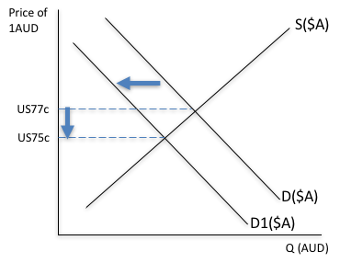

**Question 26 (12 marks)**

|  |  |
| --- | --- |
| a. i. 3%   1. Net exports (not exports) 2. The decline in the terms of trade | 1 mark  1 mark  1 mark |
| b. The economy is operating below potential GDP  The U rate is 5.9% which is well above the natural rate of U (5%) or growth rate of 3% is below the growth of potential GDP (3.25%-3.5%)  Correctly labelled AD/AS diagram showing economy in short run equilibrium to left of LRAS (potential GDP (see below) | 1 mark  1 mark  2 marks |
| c. Govt would be concerned with the decline in investment (esp. business investment)  Govt policy – note this is not monetary policy!  Fiscal measures such as infrastructure projects, reducing company taxation, offering tax incentives for firms to increase expenditure on new capital equipment – discuss 3 different measures | 1-2 marks  1-3 marks |

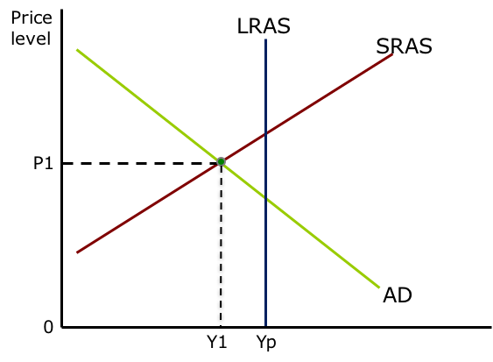

**Question 27 (12 marks)**

|  |  |
| --- | --- |
| a. i. Net foreign debt = $970,000 million (+/- $10bn)  ii. Net foreign liabilities = $900,000 million (+/- $10bn) | 1 mark  1 mark |
| b. Net foreign liabilities is the stock or accumulation of foreign investment less the stock of foreign investment abroad (foreign assets). It comprises foreign debt & foreign equity.  Net foreign liabilities increase each year because each year there is a net inflow of capital – which is the financial account surplus (= CAD). Aust relies on foreign investment to fund the I – S gap | 1 mark  1-2 marks |
| b. Public sector foreign debt has changed from negative (net lender) to positive (net borrower).  This is due to the government running budget deficits since 2009 and therefore must borrow, some of which is from foreign residents | 1 mark  1-2 marks |
| c. Any two benefits – 1 mark each  Access to foreign capital enables a higher level of investment boosting economic growth & national income – fills the I – S gap  Accessing foreign capital reduces the cost of capital Any two costs – 1 mark each  A rise in foreign debt increases interest payments which increases the income deficit (& the current account deficit)  A rise in foreign debt may result in a downgrade to Australia’s credit rating which would raise foreign borrowing costs | 1-2 marks  1-2 marks |

**Section 3 (40 marks) - Answer TWO question**

**Question 28 (20 marks)**

*The Productivity Commission reports that a tariff of up to 5 per cent continues to apply to around half of imported manufactured goods - delivering assistance to the local manufacturing sector but imposing costs on consumers and to the services sector.*

1. Use a model to demonstrate how a tariff on manufactured goods assists the local manufacturing sector but imposes costs on both consumers and the services sector.

(10 marks)

1. Discuss the benefits and costs of a free trade agreement such as ChAFTA (China Australia Free trade Agreement) to the Australian economy. (10 marks)

|  |  |
| --- | --- |
| a. Tariff diagram showing effects on price, Qd, Qs, & imports  Tariff assists local manufacturing sector by raising price of imports which reduces qty of imports & increases domestic production (& producer surplus).  Costs on consumers – they pay more & consume less; large decrease in consumer surplus  Costs on services sector – have to pay higher prices for imported inputs which raises costs | 1-3 marks  1-3 marks  1-2 marks  1-2 marks |
| b. Meaning of FTA – difference between bilateral & multilateral  Benefits – reducing trade barriers in both countries will increase exports boosting national income & reducing costs on imported goods which will increase efficiency. Note that both Xs & Ms will increase. If FTA leads to **trade creation** then very beneficial since it leads to higher real incomes  Costs – inefficient domestic industries will suffer – higher unemployment & structural change, these are short term costs An FTA can be discriminatory – this means that trade can be diverted away from more efficient countries i.e. **trade diversion** The FTA may cover only a limited range of goods/services | 1-2 marks  1-4 marks  1-4 marks |

**Question 29 (20 marks)**

1. Distinguish between the two accounts in the balance of payments and explain how the two accounts are linked. (10 marks)
2. For most of its history, Australia has had a current account deficit. Explain both the structural and cyclical reasons for Australia’s current account deficit. (10 marks)

|  |  |
| --- | --- |
| a. **Current account** – recording transactions in goods, services & income. Provide examples of each. The current account balance made up of the trade balance & the income balance. Note that the trade balance fluctuates from surplus to deficit while the income balance is always a deficit. but that the Australia records a current account deficit due to the net income deficit  **Capital/financial** – focus should be on the financial account (capital account insignificant) which records flows of financial capital (foreign investment). Australia records a financial account surplus.  The two accounts are linked because every transaction is recorded twice – so the two accounts must sum to zero  Key link – Income section of the current account records net payments of interest & dividends associated with net capital inflow in the financial account  Note: 8 marks allowed to discuss the two accounts with a 5/3 split in favour of the current account and 2 marks for the links – some flexibility here | 1-5 marks  1-3 marks  1-2 marks |
| b. Perhaps 6/4 mark split to discuss cyclical & structural factors (more on cyclical) - need to discuss at least 3 factors  **Cyclical** – related to the cyclical nature of the trade balance   * Changes in world business cycle e.g. China/US affecting demand for Aust’s exports * Changes in Aust’s business cycle affecting demand for imports * Changes in terms of trade (e.g. commodity prices) * Changes in $AUD – affecting X & M prices   **Structural** – related to Australia’s I – S gap & the net income deficit. Aust has always had a CAD due to the reliance on net capital inflow (foreign liabilities). This means that the income balance must be always in deficit due to the servicing costs – interest & dividend payments | 1-6 marks  1-4 marks |

**Question 30 (20 marks)**

1. Explain the importance of productivity and distinguish between the two measures of productivity – labour productivity and multifactor productivity. (8 marks)
2. Discuss how the government can promote productivity growth and use the AD/AS model to show the impact of productivity growth on the achievement of the government’s macroeconomic objectives. (12 marks)

|  |  |
| --- | --- |
| a. Importance of productivity – key to rising real Income & living standards over time  Labour productivity – output per unit of input; measured by GDP per hour worked; Labour productivity comprises capital deepening & MFP  MFP – measures the growth in output due to the combined increase in inputs (both K & L); MFP is a measure of technical progress | * 1. marks   2. marks   1-3 marks |
| b. Policy measures to promote productivity – discuss 4 x 2 marks |  |
| increased investment – increasing the K/L ratio. This is arguably one of the simplest ways to increase productivity – giving workers more & better capital equipment; | 1-8 marks |
| govt providing more social infrastructure – improving roads, rail networks to reduce transport costs & traffic congestion; completing NBN will increase efficiency for firms |  |
| investing in human capital – education & training |  |
| measures that promote innovation – increased incentives for research & development such as tax incentives. which will boost MFP |  |
| trade liberalisation such as FTAs will reduce costs, increase efficiency & increase productivity |  |
| AD/AS model showing shift of AS curves to the right, increasing real GDP & lowering the price level – this will help govt achieve objectives of growth, price stability & full employment | 1-2 marks for diagram  1-2 marks for explanation |

**Question 31 (20 marks)**

1. Use an appropriate model to explain the role of fiscal policy when the economy experiences a negative aggregate demand shock. (10 marks)
2. Discuss the strengths and weaknesses of fiscal policy. (10 marks)

|  |  |
| --- | --- |
| a. AD/AS diagram showing effect of negative AD shock decreasing AD – reducing real GDP, increasing U & reducing price level. Provide an example of a negative AD shock such as decrease in ToT or GFC  Need to also show that expansionary fiscal policy will shift the AD curve back again  Role of fiscal policy is countercyclical – counter the business cycle **Discretionary** changes – govt will need to implement stimulatory measures increase the budget deficit or reduce the budget surplus  – either way adopt an **expansionary** stance by increasing G and/or reducing T  Need to mention role of automatic stabilisers that will operate when economy contracts – automatic changes to G &/or T that will boost AD | 1-4 marks  1-4 marks  1-2 marks |
| b. Discuss 3 strengths = 5 marks  Strengths: very direct – changes in G &/or T will impact on real AD very quickly, effect lag is short; very effective when economy is in contraction; ability to target specific sectors  Discuss 3 weaknesses = 5 marks  Weaknesses: very inflexible – basically once a year at budget time; very long decision & implementation lags; ‘crowding out’ – deficit budget may have minimal impact if it causes a decrease in private investment; negative effect of public debt associated with deficits | 1-5 marks  1-5 marks |